Supporting Information

Highly efficient copper-catalyzed benzylic C-H alkoxylation with NFSI

Table of contents
General Information S3
General Procedures S3
Characterization Data of Products S3
Mechanistic Investigations S10
NMR Spectra of Products S20

1. General Information
General data: NMR spectra were recorded on a Bruker-400 MHz or Bruker-500 MHz spectrometer. Chemical shifts (δ) are given in ppm relative to TMS. The residual solvent signals were used as references and the chemical shifts converted to the TMS scale (CDCl₃: δH = 7.26 ppm, δC = 77.16 ppm). The high resolution mass spectra were recorded on a Thermo LTQ Orbitrap XL (ESI+) or a P-SIMS-Gly of Bruker DaltonicsInc (EI+). Infrared spectra were recorded on a Nicolet MX-1E FT-IR spectrometer. UV-vis absorption was performed with a Tu-1901 UV-vis spectrophotometer. EPR spectra were measured on a JES-FA 200 (JEOL) at 20 ℃.
Materials: All starting materials and reagents were purchased from commercial suppliers (Aldrich, Alfa, TCI, Adamas-beta, Energy chemical) and used as supplied unless otherwise stated. All solvents were purified and dried according to standard methods prior to use, unless stated otherwise.

2. General Procedures
General procedure for the synthesis of 3:
To a flame-dried and N₂-purged Schlenk tube (10 mL) were added N-Fluorobenzenesulfonimide (0.13 mmol) and alkylarene (0.1 mmol, 1.0 equiv.). The vial was sealed, purged and backfilled with N₂ three times before adding alcohol (0.5 mmol) and Cu(OAc)₂ (2×10⁻⁵ M in MeCN, 0.5 mL) through syringes. After being stirred at 80 ℃ for 12-18 hours, the solvent was removed under vacuum to provide the crude product. The residue was purified by flash chromatography (SiO₂, ethyl acetate/petroleum ether) to provide the corresponding products.

3. Characterization Data of Products
1-(1-methoxyethyl)naphthalene (3a)
Prepared according to general procedure, stirring at 80 ℃ for 12 hours. Flash chromatography (SiO₂, PE/EtOAc = 30/1) of crude product gave the title compound. Yield: 14.6 mg, 78%.
¹H NMR (400 MHz, Chloroform-d) δ 8.22 – 8.15 (m, 1H), 7.89 (dd, J = 7.0, 2.7 Hz, 1H), 7.79 (d, J = 8.1 Hz, 1H), 7.58 (d, J = 7.2 Hz, 1H), 7.55-7.47 (m, 3H), 5.07 (q, J = 6.5 Hz, 1H), 3.32 (s, 3H), 1.62 (d, J = 6.6 Hz, 3H).
¹³C NMR (101 MHz, CDCl₃) δ 139.2, 134.1, 131.0, 129.0, 127.9, 126.0, 125.7, 125.6, 123.4, 123.4, 77.5, 56.8, 23.4.
IR (film, cm⁻¹) 2977.28, 2928.57, 1511.87, 1447.58, 1370.20,1230.33, 1204.40, 1166.90, 1081.06, 1060.68, 1004.49, 800.77, 777.85.
HRMS (ESI-TOF) m/z: [M+H]⁺ Calcd for [C₁₃H₁₅O]⁺ 187.1117; Found 187.1118.
4-(1-methoxyethyl)-1,1'-biphenyl (3b)
Prepared according to general procedure, stirring at 80 ℃ for 12 hours. Flash chromatography (SiO₂, PE/EtOAc = 30/1) of crude product gave the title compound. Yield: 12.7 mg, 60%.
¹H NMR (400 MHz, Chloroform-d) δ 7.60 (dd, J = 7.5, 5.6 Hz, 4H), 7.45 (t, J = 7.6 Hz, 2H), 7.38 (dd, J = 12.9, 7.7 Hz, 3H), 4.36 (q, J = 6.5 Hz, 1H), 3.28 (s, 3H), 1.49 (d, J = 6.5 Hz, 3H).
¹³C NMR (101 MHz, CDCl₃) δ 142.7, 141.1, 140.6, 128.9, 127.4, 127.2, 126.8, 79.5, 56.7, 24.0.
IR (film, cm⁻¹) 2926.94, 1454.06, 1309.01, 1191.29, 1155.53, 1096.49, 1008.81, 701.13, 669.98, 504.84, 489.76.
HRMS (ESI-TOF) m/z: [M]⁺ Calcd for [C₁₅H₁₆O]⁺ 212.1201; Found 212.1181.
4-bromo-4'-(1-methoxyethyl)-1,1'-biphenyl (3c)
Prepared according to general procedure, stirring at 80 ℃ for 12 hours. Flash chromatography (SiO₂, PE/EtOAc = 30/1) of crude product gave the title compound. Yield: 20.3 mg, 70%.
¹H NMR (400 MHz, Chloroform-d) δ 7.55 (dd, J = 8.3, 6.6 Hz, 4H), 7.46 (d, J = 8.3 Hz, 2H), 7.39 (d, J = 8.1 Hz, 2H), 4.35 (q, J = 6.5 Hz, 1H), 3.27 (s, 3H), 1.47 (d, J = 6.5 Hz, 3H).
¹³C NMR (101 MHz, CDCl₃) δ 143.2, 140.0, 139.3, 132.0, 128.8, 127.1, 126.9, 121.6, 79.4, 56.7, 24.0.
IR (film, cm⁻¹) 2976.99, 2855.32, 1483.64, 1387.06, 1112.16, 1087.42, 1002.17, 813.89, 571.19, 521.99.
HRMS (ESI-TOF) m/z: [M+H]⁺ Calcd for [C₁₅H₁₆BrO]⁺ 291.0379; Found 291.0370.
4'-(1-methoxyethyl)-[1,1'-biphenyl]-4-carbonitrile (3d)
Prepared according to general procedure, stirring at 80 ℃ for 12 hours. Flash chromatography (SiO₂, PE/EtOAc = 5/1) of crude product gave the title compound. Yield: 15.9 mg, 67%.
¹H NMR (400 MHz, Chloroform-d) δ 7.74 – 7.67 (m, 4H), 7.58 (d, J = 8.3 Hz, 2H), 7.43 (d, J = 8.2 Hz, 2H), 4.36 (q, J = 6.5 Hz, 1H), 3.27 (s, 3H), 1.47 (d, J = 6.5 Hz, 3H)
¹³C NMR (101 MHz, CDCl₃) δ 145.5, 144.4, 138.4, 132.7, 127.8, 127.5, 127.1, 119.1, 111.0, 79.3, 56.7, 23.9.
IR (film, cm⁻¹) 3031.25, 2928.02,2819.07, 1726.28, 1599.12, 1479.13, 1452.69, 1210.87, 1115.90, 1100.80, 758.31, 705.26.
HRMS (ESI-TOF) m/z: [M+H]⁺ Calcd for [C₁₆H₁₆NO]⁺ 238.1226; Found 238.1226.
3-(1-methoxyethyl)-1,1'-biphenyl (3e)
Prepared according to general procedure, stirring at 80 ℃ for 16 hours. Flash chromatography (SiO₂, PE/EtOAc = 30/1) of crude product gave the title compound. Yield: 10.2mg, 48%.
¹H NMR (400 MHz, Chloroform-d) δ 7.62 (d, J = 7.5 Hz, 2H), 7.56 – 7.51 (m, 2H), 7.44 (q, J = 7.7 Hz, 3H), 7.36 (t, J = 7.3 Hz, 1H), 7.30 (d, J = 7.6 Hz, 1H), 4.37 (q, J = 6.5 Hz, 1H), 3.28 (s, 3H), 1.49 (d, J = 6.5 Hz, 3H).
¹³C NMR (101 MHz, CDCl₃) δ 144.3, 141.5, 141.3, 129.0, 128.9, 127.5, 127.3, 126.4, 125.3, 125.1, 79.8, 56.7, 24.1.
IR (film, cm⁻¹) 2975.19, 2926.99, 1479.18, 1210.90, 1115.90, 1100.80, 1074.76, 1002.42, 758.40, 705.35.
HRMS (ESI-TOF) m/z: [M]⁺ Calcd for [C₁₅H₁₆O]⁺ 212.1201; Found 212.1181.
(methoxymethylene)dibenzene (3f)
Prepared according to general procedure, stirring at 80 ℃ for 12 hours. Flash chromatography (SiO₂, PE/EtOAc = 30/1) of crude product gave the title compound. Yield: 11.1 mg, 56%.
¹H NMR (400 MHz, Chloroform-d) δ 7.37 – 7.29 (m, 8H), 7.26 – 7.21 (m, 2H), 5.24 (s, 1H), 3.38 (s, 3H).
¹³C NMR (101 MHz, CDCl₃) δ 142.2, 128.5, 127.6, 127.0, 85.6, 57.2.
IR (film, cm⁻¹) 2974.52, 2818.07, 1485.92, 1369.97, 1218.41, 1083.72, 1059.96, 1006.81, 991.06, 837.58, 735.12, 576.22.
HRMS (ESI-TOF) m/z: [M+Na]⁺ Calcd for [C₁₄H₁₄ONa]⁺ 221.0937; Found 221.0940.
9-methoxy-9H-fluorene (3g)
Prepared according to general procedure, stirring at 80 ℃ for 18 hours. Flash chromatography (SiO₂, PE/EtOAc = 30/1) of crude product gave the title compound. Yield: 8.2mg, 42%.
¹H NMR (400 MHz, Chloroform-d) δ 7.68 (d, J = 7.5 Hz, 2H), 7.62 (d, J = 7.3 Hz, 2H), 7.40 (t, J = 7.3 Hz, 2H), 7.32 (t, J = 7.4 Hz, 2H), 5.62 (s, 1H), 3.06 (s, 3H).
¹³C NMR (126 MHz, CDCl₃) δ 142.7, 141.1, 129.1, 127.7, 125.6, 120.1, 81.5, 52.4.
IR (film, cm⁻¹) 2929.03, 1452.58, 1197.97, 1107.13, 1070.05, 1016.61, 762.06, 742.40, 555.07, 463.04.
HRMS (ESI-TOF) m/z: [M]⁺ Calcd for [C₁₄H₁₂O]⁺ 196.0888; Found 196.0890.
2-methoxy-1,2-bis(4-methoxyphenyl)ethan-1-one (3h)
Prepared according to general procedure, stirring at 80 ℃ for 18 hours. Flash chromatography (SiO₂, PE/EtOAc = 3/1) of crude product gave the title compound. Yield: 12.6mg, 44%.
¹H NMR (400 MHz, Chloroform-d) δ 7.98 (d, J = 8.9 Hz, 2H), 7.36 (d, J = 8.7 Hz, 2H), 6.86 (dd, J = 9.0, 2.3 Hz, 4H), 5.44 (s, 1H), 3.82 (s, 3H), 3.77 (s, 3H), 3.42 (s, 3H).
¹³C NMR (101 MHz, CDCl₃) δ 195.6, 163.6, 159.8, 131.5, 129.2, 128.6, 128.0, 114.4, 113.8, 85.9, 57.4, 55.6, 55.4.
IR (film, cm⁻¹) 2931.07, 1683.32, 1600.28, 1511.06, 1253.93, 1170.60, 1101.46, 1030.12, 829.93, 573.56.
HRMS (ESI-TOF) m/z: [M+Na]⁺ Calcd for [C₁₇H₁₈O₄Na]⁺ 309.1097; Found 309.1105.
2-(1-methoxyethyl)naphthalene (3i)
Prepared according to general procedure, stirring at 80 ℃ for 12 hours. Flash chromatography (SiO₂, PE/EtOAc = 30/1) of crude product gave the title compound. Yield: 10.6 mg, 57%.
¹H NMR (400 MHz, Chloroform-d) δ 7.89 – 7.80 (m, 3H), 7.74 (s, 1H), 7.53 – 7.44 (m, 3H), 4.47 (q, J = 6.5 Hz, 1H), 3.27 (s, 3H), 1.52 (d, J = 6.5 Hz, 3H).
¹³C NMR (101 MHz, CDCl₃) δ 141.0, 133.4, 133.2, 128.5, 128.0, 127.8, 126.2, 125.9, 125.3, 124.3, 79.9, 56.7, 24.0.
IR (film, cm⁻¹) 2975.52, 2927.69, 1112.85, 1092.47, 1058.37, 1018.26, 990.86, 857.28, 820.33, 747.64, 477.54.
HRMS (ESI-TOF) m/z: [M+H]⁺ Calcd for [C₁₃H₁₅O]⁺ 187.1117; Found 187.1093.
1-(1-ethoxyethyl)naphthalene (3j)
Prepared according to general procedure, stirring at 80 ℃ for 12 hours. Flash chromatography (SiO₂, PE/EtOAc = 30/1) of crude product gave the title compound. Yield: 15.6 mg, 78%.
¹H NMR (500 MHz, Chloroform-d) δ 8.20 (d, J = 7.8 Hz, 1H), 7.88 (d, J = 7.4 Hz, 1H), 7.78 (d, J = 8.1 Hz, 1H), 7.59 (d, J = 7.0 Hz, 1H), 7.55 – 7.42 (m, 3H), 5.17 (q, J = 6.6 Hz, 1H), 3.45 (q, J = 7.0 Hz, 2H), 1.62 (d, J = 6.6 Hz, 3H), 1.24 (t, J = 7.0 Hz, 3H).
¹³C NMR (126 MHz, CDCl₃) δ 139.9, 134.0, 130.9, 129.0, 127.8, 125.9, 125.7, 125.5, 123.5, 123.3, 75.6, 64.3, 23.8, 15.7.
IR (film, cm⁻¹) 2974.68, 2928.06, 1596.35, 1442.56, 1370.04, 1174.96, 1110.83, 1082.33, 800.62, 777.73.
HRMS (ESI-TOF) m/z: [M+Na]⁺ Calcd for [C₁₄H₁₆ONa]⁺ 235.1093; Found 223.1076.
1-(1-(octyloxy)ethyl)naphthalene (3k)
Prepared according to general procedure, stirring at 80 ℃ for 18 hours. Flash chromatography (SiO₂, PE/EtOAc = 30/1) of crude product gave the title compound. Yield: 20.2 mg, 71%.
¹H NMR (500 MHz, Chloroform-d) δ 8.20 (d, J = 7.3 Hz, 1H), 7.88 (dd, J = 7.4, 2.0 Hz, 1H), 7.78 (d, J = 8.1 Hz, 1H), 7.58 (d, J = 7.0 Hz, 1H), 7.54 – 7.45 (m, 3H), 5.14 (q, J = 6.5 Hz, 1H), 3.37 (td, J = 6.7, 3.4 Hz, 2H), 1.67 – 1.52 (m, 5H), 1.41 – 1.23 (m, 10H), 0.88 (t, J = 6.9 Hz, 3H).
¹³C NMR (126 MHz, CDCl₃) δ 140.0, 134.0, 131.0, 129.0, 127.8, 125.9, 125.7, 125.5, 123.6, 123.4, 75.8, 69.1, 32.0, 30.2, 29.6, 29.4, 26.4, 23.7, 22.8, 14.3.
IR (film, cm⁻¹) 2927.81, 2855.11, 1465.51, 1369.22, 1230.10, 1171.82, 1102.99, 969.36, 799.42, 777.40.
HRMS (ESI-TOF) m/z: [M+H]⁺ Calcd for [C₂₀H₂₉O]⁺ 285.2213; Found 285.2221.
1-(1-(but-3-en-1-yloxy)ethyl)naphthalene (3l)
Prepared according to general procedure, stirring at 80 ℃ for 16 hours. Flash chromatography (SiO₂, PE/EtOAc = 30/1) of crude product gave the title compound. Yield: 17.0mg, 75%.
¹H NMR (400 MHz, Chloroform-d) δ 8.19 (dd, J = 7.1, 2.6 Hz, 1H), 7.92 – 7.83 (m, 1H), 7.78 (d, J = 8.1 Hz, 1H), 7.58 (d, J = 6.4 Hz, 1H), 7.55 – 7.44 (m, 3H), 5.83 (ddt, J = 17.1, 10.3, 6.7 Hz, 1H), 5.17 (q, J = 6.5 Hz, 1H), 5.08 (dq, J = 17.2, 1.7 Hz, 1H), 5.02 (ddt, J = 10.3, 2.2, 1.2 Hz, 1H), 3.52 – 3.38 (m, 2H), 2.38 (qt, J = 6.8, 1.4 Hz, 2H), 1.62 (d, J = 6.6 Hz, 3H).
¹³C NMR (101 MHz, CDCl₃) δ 139.7, 135.5, 134.0, 130.9, 129.0, 127.9, 125.9, 125.7, 125.6, 123.5, 123.5, 116.4, 75.9, 68.3, 34.6, 23.7.
IR (film, cm⁻¹) 3068.82, 2977.74, 2928.39, 2861.57, 1641.10, 1509.56, 1369.57, 1172.63, 1103.37, 914.11, 800.54, 777.85.
HRMS (ESI-TOF) m/z: [M+H]⁺ Calcd for [C₁₆H₁₉O]⁺ 227.1430; Found 227.1453.
1-(1-(but-3-yn-1-yloxy)ethyl)naphthalene (3m)
Prepared according to general procedure, stirring at 80 ℃ for 18 hours. Flash chromatography (SiO₂, PE/EtOAc = 30/1) of crude product gave the title compound. Yield: 11.6mg, 75%.
¹H NMR (400 MHz, Chloroform-d) δ 8.22 – 8.15 (m, 1H), 7.92 – 7.85 (m, 1H), 7.78 (d, J = 8.1 Hz, 1H), 7.60 (d, J = 7.1 Hz, 1H), 7.55 – 7.43 (m, 3H), 5.21 (q, J = 6.5 Hz, 1H), 3.63 – 3.45 (m, 2H), 2.50 (td, J = 6.9, 2.6 Hz, 2H), 1.97 (t, J = 2.7 Hz, 1H), 1.64 (d, J = 6.5 Hz, 3H).
¹³C NMR (126 MHz, CDCl₃) δ 139.2, 134.1, 130.9, 129.0, 128.0, 126.0, 125.7, 125.6, 123.6, 123.5, 81.6, 76.2, 69.4, 66.9, 29.9, 23.6, 20.3.
IR (film, cm⁻¹) 3295.44, 2976.01, 2926.72, 1596.37, 1509.52, 1395.42, 1171.85, 1106.11, 1008.52, 801.68, 778.65, 640.50, 558.84.
HRMS (ESI-TOF) m/z: [M+H]⁺ Calcd for [C₁₆H₁₇O]⁺ 225.1274; Found 225.1284.
1-(1-(2-fluoroethoxy)ethyl)naphthalene (3n)
Prepared according to general procedure, stirring at 80 ℃ for 16 hours. Flash chromatography (SiO₂, PE/EtOAc = 30/1) of crude product gave the title compound. Yield: 10.5mg, 48%.
¹H NMR (400 MHz, Chloroform-d) δ 8.18 (d, J = 8.2 Hz, 1H), 7.88 (dd, J = 7.1, 2.2 Hz, 1H), 7.78 (d, J = 8.1 Hz, 1H), 7.68 – 7.53 (m, 1H), 7.56 – 7.44 (m, 3H), 5.23 (q, J = 6.6 Hz, 1H), 4.62 (dd, J = 4.9, 3.4 Hz, 1H), 4.50 (dd, J = 4.9, 3.4 Hz, 1H), 3.66 (dd, J = 5.2, 3.2 Hz, 1H), 3.64 – 3.55 (dd, 5.2, 3.2Hz, 1H), 1.66 (d, J = 6.5 Hz, 3H).
¹³C NMR (101 MHz, Chloroform-d) δ 138.9, 134.1, 130.8, 129.1, 128.1, 126.1, 125.7, 125.7, 123.6, 123.4, 83.4 (d, J = 169.1 Hz), 67.9 (d, J = 19.6 Hz), 67.8, 23.6
IR (film, cm⁻¹) 2978349, 2929.02, 1596.33, 1509.98, 1455.47, 1369.76, 1173.48, 1119.56, 1049.28, 942.44, 876.65, 802.42, 779.25.
HRMS (ESI-TOF) m/z: [M]⁺ Calcd for [C₁₄H₁₅FO]⁺ 218.1107; Found 218.1119.
methyl 2-(1-(naphthalen-1-yl)ethoxy)acetate (3o)
Prepared according to general procedure, stirring at 80 ℃ for 16 hours. Flash chromatography (SiO₂, PE/EtOAc = 2/1) of crude product gave the title compound. Yield: 13.2mg, 54%.
¹H NMR (400 MHz, Chloroform-d) δ 8.16 (d, J = 7.3 Hz, 1H), 7.92 – 7.85 (m, 1H), 7.80 (d, J = 8.1 Hz, 1H), 7.58 (d, J = 7.1 Hz, 1H), 7.56 – 7.43 (m, 3H), 5.33 (q, J = 6.5 Hz, 1H), 4.10 (d, J = 16.4 Hz, 1H), 3.95 (d, J = 16.4 Hz, 1H), 3.73 (s, 3H), 1.70 (d, J = 6.5 Hz, 3H).
¹³C NMR (126 MHz, CDCl₃) δ 171.1, 138.1, 134.1, 130.9, 129.1, 128.4, 126.2, 125.8, 125.7, 123.8, 123.4, 76.5, 66.0, 51.9, 23.5.
IR (film, cm⁻¹) 2979.07, 2951.84, 1754.81, 1437.67, 1371.55, 1171.06, 1120.43, 1003.37802.79, 779.54.
HRMS (ESI-TOF) m/z: [M+Na]⁺ Calcd for [C₁₅H₁₆O₃Na]⁺ 267.0992; Found 267.0999.
1-(1-((3-bromobenzyl)oxy)ethyl)naphthalene (3p)
Prepared according to general procedure, stirring at 80 ℃ for 14 hours. Flash chromatography (SiO₂, PE/EtOAc = 20/1) of crude product gave the title compound. Yield: 13.9mg, 41%.
¹H NMR (500 MHz, Chloroform-d) δ 8.21 – 8.16 (m, 1H), 7.93 – 7.87 (m, 1H), 7.81 (d, J = 8.2 Hz, 1H), 7.62 (d, J = 7.1 Hz, 1H), 7.51 (m , 4H), 7.41 (dt, J = 7.7, 1.8 Hz, 1H), 7.30 – 7.18 (m, 2H), 5.25 (q, J = 6.5 Hz, 1H), 4.49 (d, J = 12.1 Hz, 1H), 4.33 (d, J = 12.1 Hz, 1H), 1.68 (d, J = 6.5 Hz, 3H).
¹³C NMR (126 MHz, CDCl₃) δ 141.2, 139.0, 134.1, 130.9, 130.7, 130.7, 130.1, 129.1, 128.2, 126.2, 126.1, 125.7, 123.8, 123.5, 122.7, 75.7, 69.9, 23.7.
IR (film, cm⁻¹) 2976.03, 2927.20, 1596.21, 1570.36, 1427.32, 1369.49, 1170.91, 1099.98, 1005.85, 800.92, 777.22.
HRMS (ESI-TOF) m/z: [M+H]⁺ Calcd for [C₁₉H₁₈BrO]⁺ 341.0536; Found 341.0546.
1-(1-phenethoxyethyl)naphthalene (3q)
Prepared according to general procedure, stirring at 80 ℃ for 14 hours. Flash chromatography (SiO₂, PE/EtOAc = 20/1) of crude product gave the title compound. Yield: 19.3mg, 70%.
¹H NMR (400 MHz, Chloroform-d) δ 8.13 (dt, J = 7.0, 3.5 Hz, 1H), 7.87 (dt, J = 6.2, 3.3 Hz, 1H), 7.76 (d, J = 8.0 Hz, 1H), 7.53 – 7.39 (m, 4H), 7.31 – 7.23 (m, 3H), 7.24 – 7.16 (m, 3H), 5.17 (q, J = 6.5 Hz, 1H), 3.61 (td, J = 7.2, 1.8 Hz, 2H), 2.95 (hept, J = 6.7 Hz, 2H), 1.61 (d, J = 6.5 Hz, 3H).
¹³C NMR (101 MHz, CDCl₃) δ 139.6, 139.2, 134.0, 130.9, 129.1, 129.0, 128.4, 127.8, 126.2, 125.9, 125.7, 125.5, 123.5, 76.0, 69.9, 36.8, 23.6.
IR (film, cm⁻¹) 2975.19, 2927.35, 1596.32, 1453.29, 1369.38, 1230.47, 1170.96, 1103.26, 800.71, 777.98,749.70, 698.74.
HRMS (ESI-TOF) m/z: [M+Na]⁺ Calcd for [C₂₀H₂₀ONa]⁺ 299.1406; Found 299.1413.
1-(1-(4-methylphenethoxy)ethyl)naphthalene (3r)
Prepared according to general procedure, stirring at 80 ℃ for 16 hours. Flash chromatography (SiO₂, PE/EtOAc = 20/1) of crude product gave the title compound. Yield: 17.7mg, 77%.
¹H NMR (500 MHz, Chloroform-d) δ 8.14 (dt, J = 7.0, 3.6 Hz, 1H), 7.91 – 7.84 (m, 1H), 7.77 (d, J = 8.1 Hz, 1H), 7.59 – 7.39 (m, 4H), 7.11 – 7.05 (m, 4H), 5.17 (q, J = 6.5 Hz, 1H), 3.67 – 3.53 (m, 2H), 2.97 – 2.83 (m, 2H), 2.32 (s, 3H), 1.61 (d, J = 6.6 Hz, 3H).
¹³C NMR (126 MHz, CDCl₃) δ 139.6, 136.0, 135.7, 134.0, 130.9, 129.1, 129.0, 127.8, 125.9, 125.7, 125.5, 123.5, 75.9, 70.1, 36.3, 23.6, 21.2.
IR (film, cm⁻¹) 2928.61, 2861.15, 1514.62, 1368.99, 1230.42, 1170.96, 1103.57, 1008.67, 800.67, 777.83.
HRMS (ESI-TOF) m/z: [M+Na]⁺ Calcd for [C₂₁H₂₂ONa]⁺ 313.1563; Found 313.1568.
1-(1-(4-bromophenethoxy)ethyl)naphthalene (3s)
Prepared according to general procedure, stirring at 80 ℃ for 14 hours. Flash chromatography (SiO₂, PE/EtOAc = 20/1) of crude product gave the title compound. Yield: 27.2mg, 77%.
¹H NMR (500 MHz, Chloroform-d) δ 8.13 – 8.07 (m, 1H), 7.87 (dd, J = 7.2, 2.5 Hz, 1H), 7.77 (dd, J = 7.0, 2.5 Hz, 1H), 7.55 – 7.39 (m, 4H), 7.37 (d, J = 8.3 Hz, 2H), 7.06 (d, J = 8.4 Hz, 2H), 5.13 (q, J = 6.5 Hz, 1H), 3.58 (t, J = 6.8 Hz, 2H), 2.87 (t, J = 6.6 Hz, 3H), 1.60 (d, J = 6.6 Hz, 3H).
¹³C NMR (126 MHz, CDCl₃) δ 139.4, 138.4, 134.0, 131.4, 130.9, 130.9, 129.0, 128.0, 126.0, 125.7, 125.6, 123.5, 123.5, 120.1, 76.2, 69.4, 36.2, 23.6.
IR (film, cm⁻¹) 2975.45, 2928.17, 1508.93, 1488.18, 1440.51, 1369.51, 1230.35, 1170.98, 1104.44, 1072.10, 1011.31, 801.19, 777.95.
HRMS (ESI-TOF) m/z: [M+H]⁺ Calcd for [C₂₀H₂₀BrO]⁺ 355.0692; Found 355.0717.
1-(1-isopropoxyethyl)naphthalene (3t)
Prepared according to general procedure, stirring at 80 ℃ for 16 hours. Flash chromatography (SiO₂, PE/EtOAc = 30/1) of crude product gave the title compound. Yield: 12.4 mg, 58%.
¹H NMR (400 MHz, Chloroform-d) δ 8.25 – 8.19 (m, 1H), 7.88 (dd, J = 7.1, 2.5 Hz, 1H), 7.77 (d, J = 8.0 Hz, 1H), 7.62 (d, J = 7.0 Hz, 1H), 7.60 – 7.44 (m, 3H), 5.30 (q, J = 6.6 Hz, 1H), 3.55 (hept, J = 6.1 Hz, 1H), 1.59 (d, J = 6.5 Hz, 3H), 1.21 (d, J = 6.0 Hz, 3H), 1.15 (d, J = 6.2 Hz, 3H).
¹³C NMR (101 MHz, CDCl₃) δ 140.4, 133.9, 130.8, 128.9, 127.6, 125.7, 125.6, 125.4, 123.5, 123.4, 72.3, 68.8, 24.2, 23.4, 21.4.
IR (film, cm⁻¹) 2972.20, 2929.32, 1463.87, 1368.88, 1150.65, 1107.20, 1094.68, 1021.69, 800.45, 777.87.
HRMS (ESI-TOF) m/z: [M+H]⁺ Calcd for [C₁₅H₁₉O]⁺ 215.1430; Found 215.1428.
1-(1-(cyclohexyloxy)ethyl)naphthalene (3u)
Prepared according to general procedure, stirring at 80 ℃ for 18 hours. Flash chromatography (SiO₂, PE/EtOAc = 30/1) of crude product gave the title compound. Yield: 11.7 mg, 46%.
¹H NMR (400 MHz, Chloroform-d) δ 8.20 (d, J = 7.3 Hz, 1H), 7.91 – 7.84 (m, 1H), 7.77 (d, J = 8.2 Hz, 1H), 7.64 (d, J = 7.1 Hz, 1H), 7.55 – 7.43 (m, 3H), 5.35 (q, J = 6.5 Hz, 1H), 3.23 (tt, J = 9.8, 3.9 Hz, 1H), 2.04 (d, J = 12.4 Hz, 1H), 1.85 – 1.64 (m, 2H), 1.58 (d, J = 6.5 Hz, 3H), 1.54 – 1.30 (m, 4H), 1.22 – 1.07 (m, 3H).
¹³C NMR (126 MHz, CDCl₃) δ 140.8, 134.0, 130.9, 129.0, 127.6, 125.8, 125.7, 125.5, 123.6, 123.5, 75.2, 72.0, 33.7, 32.0, 26.0, 24.6, 24.5, 24.3.
IR (film, cm⁻¹) 2930.57, 2854.81, 1449.58, 1367.24, 1259.16, 1170.94, 1100.40, 1024.22, 800.07, 777.70.
HRMS (ESI-TOF) m/z: [M+H]⁺ Calcd for [C₁₈H₂₃O]⁺ 255.1743; Found 255.1748.
Unsuccessful substrates

4. Mechanistic Investigations
General procedure for the dynamic experiment:
To a flame-dried and N₂-purged Schlenk tube (10 mL) were added N-FluorobenzenesulfoniMide (0.13 mmol) and 1c (0.1 mmol, 1.0 equiv.). The vial was sealed, purged and backfilled with N₂ three times before adding 2a (0.5 mmol) and Cu(OAc)₂ (2×10⁻³ to 2×10⁻⁷ M in MeCN, 0.5 mL) through syringes. After being stirred at 80 ℃ for several hours, triacetyl benzene was added as an internal standard. The solvent was removed under vacuum to provide the crude product. The concentration of 1c, 3c, 4 was monitored by ¹H-NMR.

Table S1 Reaction profiles at 1 mol% loading amount of Cu(OAc)₂
Time (min) | Conversion of 1c (10⁻³ M) | Concentration of 3c (10⁻³ M)
10 | 10 | 0
20 | 20
30 | 30 | 16
60 | 16 | 30
90 | 58
120 |  | 46
180 |  | 60

Table S2 Reaction profiles at 0.1 mol% loading amount of Cu(OAc)₂
Time (min) | Conversion of 1c (10⁻³ M) | Concentration of 3c (10⁻³ M)
20 | 0
30 | 6 | 0
60 | 26 | 14
90 | 36
120 | 50 | 32
180 |  | 42
240 |  | 56

Table S3 Reaction profiles at 0.01 mol% loading amount of Cu(OAc)₂
Time (min) | Conversion of 1c (10⁻³ M) | Concentration of 3c (10⁻³ M)
30 | 0 | 0
60 | 16 | 6
90 | 24
120 | 34 | 20
150 | 42
180 | 52 | 32
240 |  | 42
300 |  | 52

Table S4 Reaction profiles at 0.001 mol% loading amount of Cu(OAc)₂

Time (min) | Conversion of 1c (10⁻³ M) | Concentration of 3c (10⁻³ M)
60 | 0 | 0
90 | 8
120 | 20 | 14
150 | 28
180 | 38 | 24
240 | 48 | 36
300 |  | 46

Table S5 Reaction profiles at 0.0001 mol% loading amount of Cu(OAc)₂
Time (min) | Conversion of 1c (10⁻³ M) | Concentration of 3c (10⁻³ M)
90 | 0 | 0
120 | 10 | 6
150 | 14
180 | 20 | 12
240 | 32 | 22
300 | 46 | 34

Table S6 Concentration of 4 at 1 mol% loading amount of Cu(OAc)₂
Time (h) | Concentration of 4（10⁻³ M）
6 | 16
7 | 28
8 | 40
9 | 54
10 | 62

Table S7 Concentration of 4 at 0.1 mol% loading amount of Cu(OAc)₂
Time (h) | Concentration of 4（10⁻³ M）
6 | 0
7 | 12
8 | 20
9 | 34
10 | 44
12 | 56

Table S8 Concentration of 4 at 0.01 mol% loading amount of Cu(OAc)₂
Time (h) | Concentration of 4（10⁻³ M）
6 | 0
7 | 6
8 | 16
9 | 24
10 | 32
12 | 50

Table S9 Concentration of 4 at 0.001 mol% loading amount of Cu(OAc)₂
Time (h) | Concentration of 4（10⁻³ M）
8 | 0
9 | 10
10 | 20
12 | 34
14 | 52

Table S10 Concentration of 4 at 0.0001 mol% loading amount of Cu(OAc)₂
Time (h) | Concentration of 4（10⁻³ M）
9 | 0
10 | 8
12 | 28
14 | 44
16 | 62

Fig S1. Conversion of 1c at different loading amount of Cu(OAc)₂
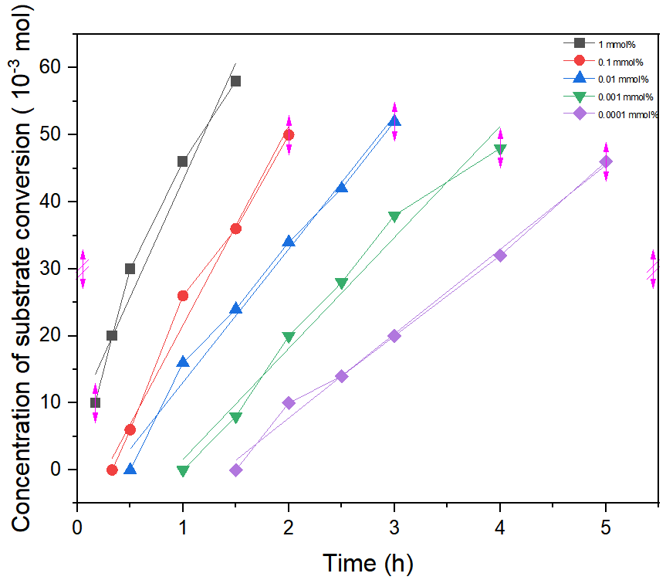

Table S11 Linear fitting equation data of conversion of 1c at different loading amount of Cu(OAc)₂
Linear fitting equation | y = a+bx
catalyst loading | 1 mol% | 0.1 mol% | 0.01 mol% | 0.001 mol% | 0.0001 mol%
intercept | 8.343 | -8.047 | -6.8 | -15 | -17.431
slope | 34.939 | 29.688 | 19.886 | 16.571 | 12.588
R² | 0.966 | 0.986 | 0.987 | 0.98 | 0.993

Fig S2. Concentration of 3c at different loading amount of Cu(OAc)₂
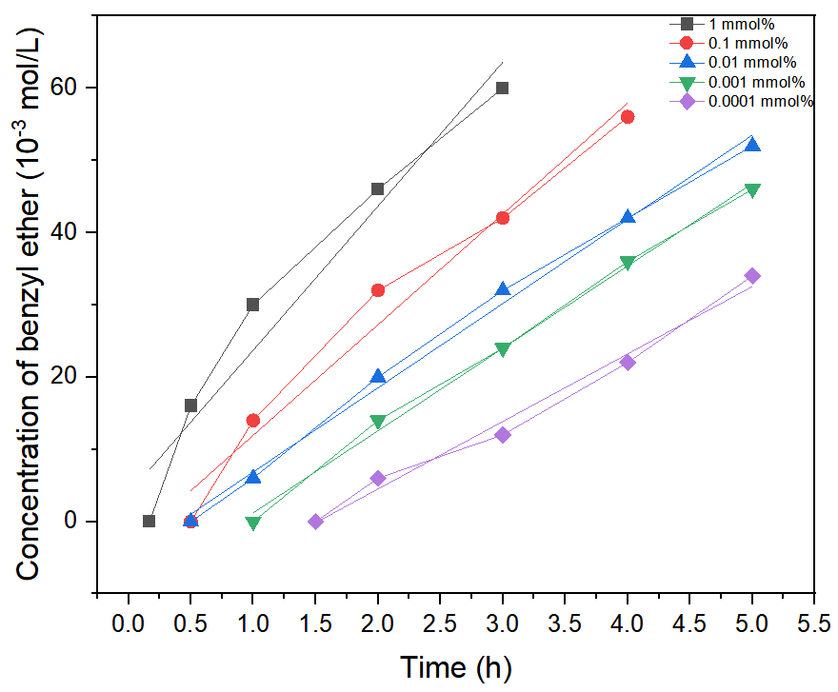

Table S12 Linear fitting equation data of concentration of 3c at different loading amount of Cu(OAc)₂
Linear fitting equation | y = a+bx
catalyst loading | 1 mol% | 0.1 mol% | 0.01 mol% | 0.001 mol% | 0.0001 mol%
intercept | 3.817 | -3.366 | -4.789 | -10.2 | -14.159
slope | 19.927 | 15.317 | 11.66 | 11.4 | 9.341
R² | 0.949 | 0.975 | 0.995 | 0.997 | 0.987

Fig S3. Concentration of 4 at different loading amount of Cu(OAc)₂
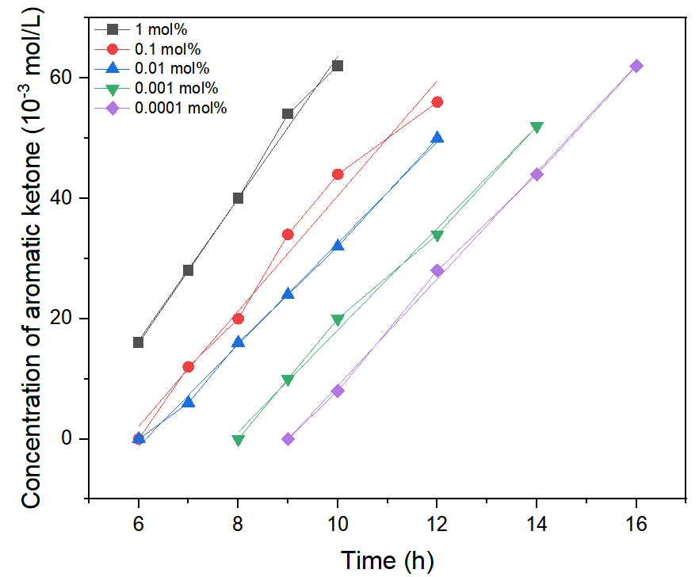

Table S13 Linear fitting equation data of concentration of 4 at different loading amount of Cu(OAc)₂
Linear fitting equation | y = a+bx
catalyst dosage | 1 mol% | 0.1 mol% | 0.01 mol% | 0.001 mol% | 0.0001 mol%
intercept | -54.4 | -55.286 | -51.714 | -66.534 | -80.061
slope | 11.8 | 9.571 | 8.429 | 8.466 | 8.89
R² | 0.995 | 0.981 | 0.998 | 0.996 | 0.999

General procedure for control experiment:
To a flame-dried and N₂-purged Schlenk tube (10 mL) were added N-FluorobenzenesulfoniMide (0.13 mmol) and 4-bromo-4'-(1-methoxyethyl)-1,1'-biphenyl (0.1 mmol, 1.0 equiv.). The vial was sealed, purged and backfilled with N₂ three times before adding Cu(OAc)₂ (2×10⁻³ - 2×10⁻⁷ M in MeCN, 0.5 mL) through a syringe. After being stirred at 80 ℃ overnight, triacetyl benzene was added as an internal standard. The solvent was removed under vacuum to provide the crude product. The yield of 1-(4'-bromo-[1,1'-biphenyl]-4-yl)ethan-1-one was monitored by ¹H-NMR.
General procedure for the UV-vis absorption experiment:
(1) Anhydrous Cu(OAc)₂ (0.1mmol, 18.1 mg) and acetonitrile (50 mL) were added in a 100 mL snap vial. After completely dissolved, 20 μl of the solution was extracted with 25 μl syringe and diluted with acetonitrile to 2mL. The solution (2 mL) was transferred into a colorimetric dish. Then the UV-vis measurement was carried out at 20 ℃. (2) NFSI (0.05 mmol, 15.8 mg) and acetonitrile (2 mL) were added in a 5 mL snap vial. After completely dissolved, 0.5 mL of this solution was extracted with 1mL syringe to diluted with acetonitrile to 2 mL. The solution (2 mL) was transferred into a colorimetric dish. Then the UV-vis measurement was carried out at 20 ℃. (3) NFSI (0.05 mmol, 15.8 mg), Cu(OAc)₂ (2×10⁻³ M in MeCN, 80μl) and acetonitrile (2 mL) were added in a 5 mL snap vial. After completely dissolved, 0.5 mL of this solution was extracted with 1mL syringe to diluted with acetonitrile to 2 mL. The solution (2 mL) was transferred into a colorimetric dish. Then the UV-vis measurement was carried out at 20 ℃.
Fig S4. UV-visible absorption spectrum
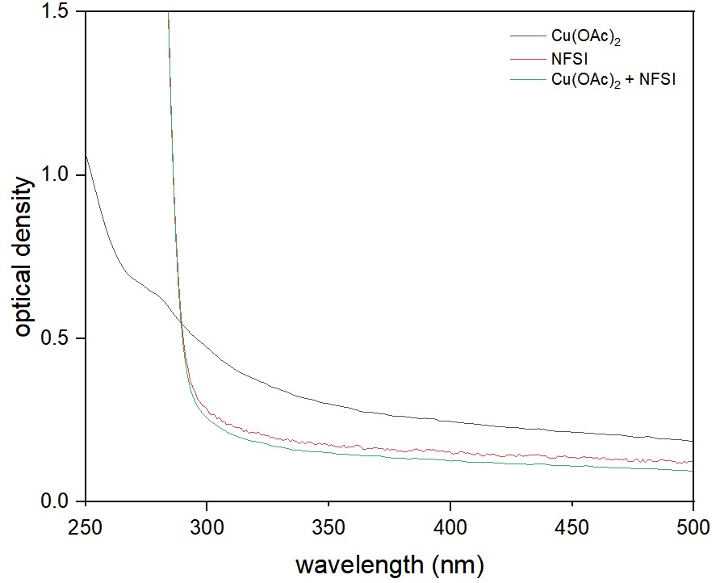
General procedure for the EPR experiment:
(1) Anhydrous Cu(OAc)₂ (0.1 mmol, 18.1 mg) and acetonitrile (50 mL) were added in a 100 mL snap vial. After completely dissolved, the solution (0.5 mL) was transferred into an EPR tube. Then the EPR measurement was carried out at 20 ℃. (2) Cu(OAc)₂ (2×10⁻³ M in MeCN, 2 mL) and MeOH (40 μl) were added in a 5 mL snap vial. After completely dissolved, the solution (0.5 mL) was transferred into an EPR tube. Then the EPR measurement was carried out at 20 ℃. (3) Cu(OAc)₂ (2×10⁻³ M in MeCN, 2 mL) and NFSI (0.05 mmol, 15.8 mg) were added in a 5 mL snap vial. After completely dissolved, the solution (0.5 mL) was transferred into an EPR tube. Then the EPR measurement was carried out at 20 ℃. (4) Cu(OAc)₂ (2×10⁻³ M in MeCN, 2mL), MeOH (40 μl) and NFSI (0.05 mmol, 15.8 mg) were added in a 5 mL snap vial. After completely dissolved, the solution (0.5 mL) was transferred into an EPR tube. Then the EPR measurement was carried out at 20 ℃. (5) Cu(OAc)₂ (2×10⁻³ M in MeCN, 2 mL) and (PhSO₂)₂N−Na (0.05 mmol, 16.0 mg) were added in a 5 mL snap vial. After completely dissolved, the solution (0.5 mL) was transferred into an EPR tube. Then the EPR measurement was carried out at 20 ℃.
Fig S5. EPR spectroscopy spectrum
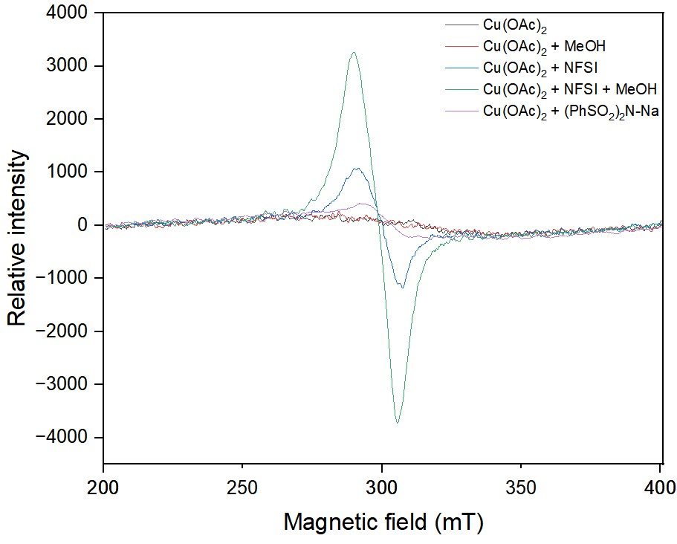
General procedure for the substituent effect experiment:
To a flame-dried and N₂-purged Schlenk tube (10 mL) were added N-Fluorobenzenesulfonimide (0.13 mmol) and 1 (0.1 mmol, 1.0 equiv). The vial was sealed, purged and backfilled with N₂ three times before adding 2a (0.5 mmol) and Cu(OAc)₂ (2×10⁻⁵ M in MeCN, 0.5 mL). through a syringe. After being stirred at 80 ℃ for several hours, triacetyl benzene was added as an internal standard. The solvent was removed under vacuum to provide the crude product. The concentration of 1 was monitored by ¹H-NMR.

Table S14 Conversion of 1 at 0.01 mol% loading amount of Cu(OAc)₂
Time (h) | Conversion of 1v (mM) | Conversion of 1w (mM) | Conversion of 1b (mM) | Conversion of 1c (mM) | Conversion of 1d (mM)
0.25 | 3
0.5 | 10 | 6 | 0 | 0 | 0
1 | 24 | 18 | 20 | 16 | 8
1.5 | 38 | 30 | 32 | 24 | 16
2 | 54 | 44 | 40 | 34 | 26
2.5 |  | 56 | 48 | 42 | 36
3 |  |  | 60 | 52 | 45

Fig S6. Conversion of 1 at 0.01 mol% loading amount of Cu(OAc)₂
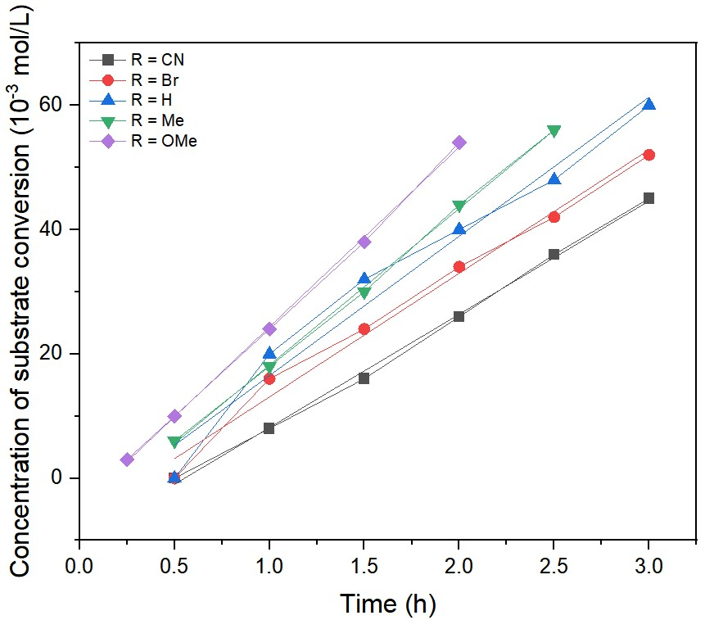
Fig S6. Effect of substituents on reaction rate constants
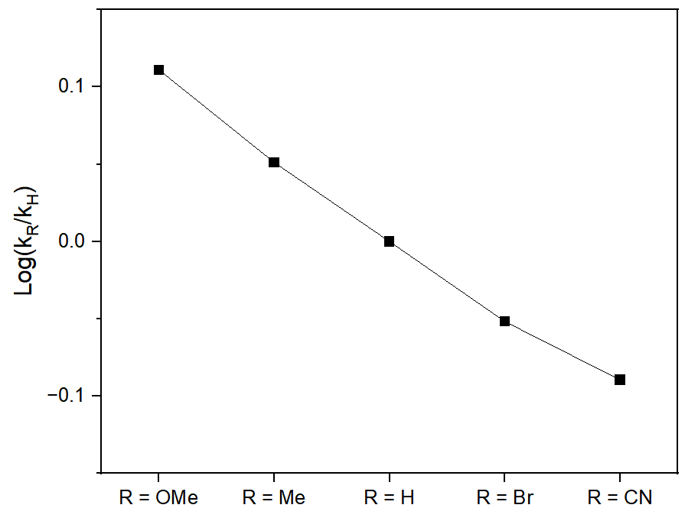
General procedure for the dynamic experiment by using Cu(MeCN)₄PF₆ as catalyst:
To a flame-dried and N₂-purged Schlenk tube (10 mL) were added N-FluorobenzenesulfoniMide (0.13 mmol) and 1c (0.1 mmol, 1.0 equiv.). The vial was sealed, purged and backfilled with N₂ three times before adding 2a (0.5 mmol) and Cu(MeCN)₄PF₆ (2×10⁻⁵ M in MeCN, 0.5 mL) through syringes. After being stirred at 80 ℃ for several hours, triacetyl benzene was added as an internal standard. The solvent was removed under vacuum to provide the crude product. The concentration of 1c, 3c, was monitored by ¹H-NMR.

Table S15 Reaction profiles at 0.01 mol% loading amount of Cu(MeCN)₄PF₆
Time (min) | Conversion of 1c (10⁻³ M) | Concentration of 3c (10⁻³ M)
10 | 20 | 16
20 | 29 | 24
30 | 40 | 37

Fig S7. Conversion of 1c and concentration of 3c at 0.01 mmol% loading amount of Cu(MeCN)₄PF₆
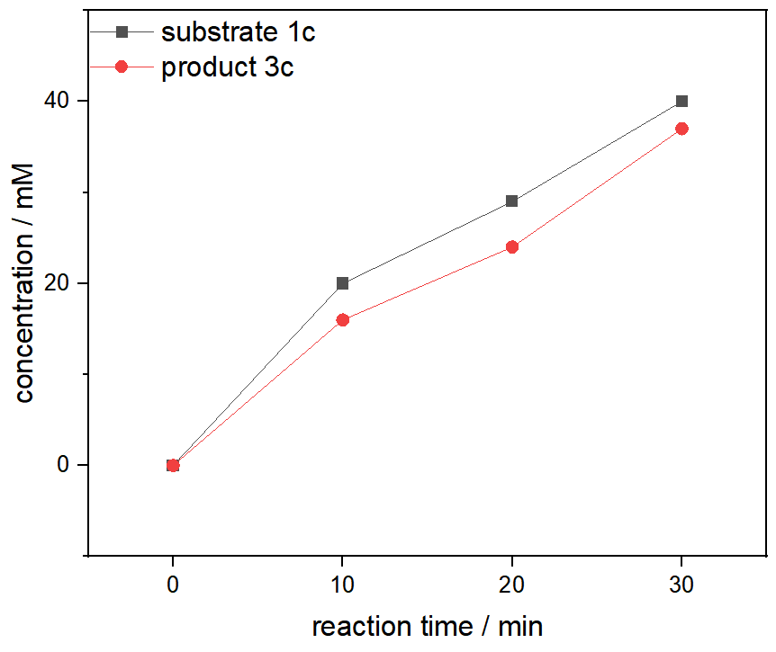

NMR Spectra of Products
¹H NMR spectrum of 3a
¹³C NMR spectrum of 3a

¹H NMR spectrum of 3b
¹³C NMR spectrum of 3b

¹H NMR spectrum of 3c
¹³C NMR spectrum of 3c

¹H NMR spectrum of 3d
¹³C NMR spectrum of 3d

¹H NMR spectrum of 3e
¹³C NMR spectrum of 3e

¹H NMR spectrum of 3f
¹³C NMR spectrum of 3f

¹H NMR spectrum of 3g
¹³C NMR spectrum of 3g

¹H NMR spectrum of 3h
¹³C NMR spectrum of 3h

¹H NMR spectrum of 3i
¹³C NMR spectrum of 3i

¹H NMR spectrum of 3j
¹³C NMR spectrum of 3j

¹H NMR spectrum of 3k
¹³C NMR spectrum of 3k

¹H NMR spectrum of 3l
¹³C NMR spectrum of 3l

¹H NMR spectrum of 3m
¹³C NMR spectrum of 3m

¹H NMR spectrum of 3n
¹³C NMR spectrum of 3n

¹H NMR spectrum of 3o
¹³C NMR spectrum of 3o

¹H NMR spectrum of 3p
¹³C NMR spectrum of 3p

¹H NMR spectrum of 3q
¹³C NMR spectrum of 3q

¹H NMR spectrum of 3r
¹³C NMR spectrum of 3r

¹H NMR spectrum of 3s
¹³C NMR spectrum of 3s

¹H NMR spectrum of 3t
¹³C NMR spectrum of 3t

¹H NMR spectrum of 3u
¹³C NMR spectrum of 3u

